Case Study: ABC Analysis

Business Scenario

The GBI Company is a wholesaler trading in bicycles and accessories such as helmets and brakes. This year the company has experienced huge drops in sales due to the bad market situation as well as a cold summer. To identify some countermeasures to increase the sales numbers again, the chief marketing officer has hired you as a consultant. Your task is to increase respective numbers. First, you want to get an overview of the customers as well as past marketing promotions. Unfortunately, you realize that most past marketing activities have been uncoordinated and random.

Your strategy is to implement cross- and upselling strategies as well as to offer better customer service, especially for your best customers. As marketing expert, you know the 80/20 rule of thumb which states that 80% of the sales revenues are typically generated by 20% of the customers. So you need to identify your best customers. Therefore, you categorize your customers in three groups – A, B and C. A-customers are your best customers who generate the most revenue, B-customers are your normal customers with frequent sales and C-customers are the smallest customers with less revenue or one-time sales. Your aim is to present the importance of the A-customers to the chief marketing officer.

To allow a fast processing, the sales data is stored in a separate table in the HANA database (see Figure 1).

|  |  |
| --- | --- |
| ***Shopping Basket data***  Table definition | Table contents |

Figure 1: Table GBI_SALES_ABC

To provide additional information related to customers and products, an analytic view has been created on top of the provided table GBI_DEMO1_SALES_ABC. This view joins the shopping transaction with master data for customers (see Figure 2).

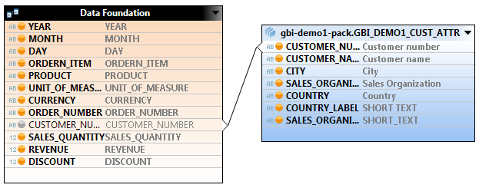

Figure 2: Analytic View GBI_DEMO1_ABC_ANALYSIS_AV

Furthermore, a calculated column has been created which converts from US Dollars into Euros.

Your job is to create an ABC analysis on the analytical view shown above in order to identify the top customers with the highest revenue. For this task, you will use the tool, SAP Predictive Analysis. The appropriate algorithm is the algorithm “HANA ABC Analysis”. The result of this algorithm is a classification of customers into A-, B- and C-customers.

1. Create a dataset

At first, you will create a new document in SAP Predictive Analysis that includes all relevant information of your analysis, e.g. the dataset, results and visualizations.

As indicated in the business scenario, you will use the analytic view GBI_DEMO1_ABC_ANALYSIS_AV as source for your dataset.

As you want to ensure fast data processing, you will directly connect to SAP HANA and run the ABC algorithm in the HANA database.

* 1. Create a new document in SAP Predictive Analysis

**Hint**: You can create a new document using the menu path *File -> New*, or by clicking on the  button.

* 1. Select SAP HANA as data source

Select “Connect to SAP HANA”.

Enter the logon information.

**Server:** *Provided by the instructor*

**Instance/Port:** *Provided by the instructor*

**User:** *Provided by the instructor*

**Password:** *Provided by the instructor*

Connect to SAP HANA.

* 1. Select the analytic view GBI_DEMO1_ABC_ANALYSIS_AV

Select the analytic view GBI_DEMO1_ABC_ANALYSIS_AV.

**Hint:** The view is located in the package gbi-demo1-pack.

Click on *NEXT*.

* 1. Choose Measures and Dimensions

Please select the following measures and dimensions:

|  |  |
| --- | --- |
| **Measure Name** | **Dimension** |
| Revenue in EUR | Customer name |
|  | Customer number |

Click on *CREATE*

What would happen, if you do not pre-select respective dimensions?

1. Analyze the data

Before you configure the algorithm, you want to get a deeper understanding of the data. Therefore you visualize the data and its statistical attributes.

You will gain rough insights about your existing customers.

**Hint:** Predictive Analysis provides the possibility for statistical analysis of the data (mean, standard deviation etc.). Therefore, you should “run the model” without any algorithms in the *PREDICT* tab. This will load the data from HANA into Predictive Analysis and display statistical values.

* 1. Navigate to the PREDICT Tab in your document

Click the button *PREDICT* located on the top of the workspace.

* 1. Analyze the data

Your dataset, the analytic view “GBI_DEMO1_ABC_ANALYSIS_AV,” should already be available in the workspace. To display statistical values about the analytical view, you should run the model *without*selecting any algorithm. Click on *RUN* which is located in the top left part of the screen. 

Hint: A popup occurs informing you that the scripts have been generated successfully. Confirm with *OK*.

Click on the first icon under *DATA INSIGHT*  and analyze the data. Answer the following questions:

1. How many distinct customers does the wholesaler GBI have?
2. What is the average revenue that GBI receives from their customers?
3. How many customers with a revenue of approximately 10 million Euros does GBI have?
4. Apply the algorithm

After you have analyzed the dataset, you will configure the ABC algorithm.

Since you want to group customers into A-, B- and C-customers, you will categorize them according to the revenue they have created.

Your plan is to prioritize A-customers. Therefore, you need to write back your results to the HANA database. When a customer calls, the service agent should get a notification regarding of the category to which the customer belongs.

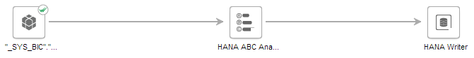

* 1. Navigate to the DESIGNER in the PREDICT tab in your document

If you are not already located in the *PREDICT* tab, click on *PREDICT* on the top of your workspace. Then click on *DESIGNER* on the top left part of the workspace.

* 1. Add and configure the ABC algorithm

Add the HANA ABC analysis algorithm from the components panel on the right hand side to the workspace, using drag and drop.

**Note:** The algorithm is linked automatically to your dataset.

Double click on the HANA ABC Algorithm icon in the workspace to configure the algorithm.

* 1. Configure following settings on the properties tab:

**Feature:** *Revenue in EUR*

**Percentage A:**  *20*

**Percentage B:** *60*

**Percentage C:** *20*

**Predicted Column Name:** *ABC_Category*

* 1. Add a HANA writer to your analysis

Add a HANA writer from the components panel on the right hand side to the workspace, using drag and drop.

**Hint:** You find the HANA writer in the Data Writers section of the components panel.

Double click on the HANA writer icon on the workspace to configure the algorithm.

Configure following settings on the properties tab:

**Schema name:** *Your user ID*

**Table name:** *ABC_## (## is your group number provided by the instructor)*

* 1. Run the analysis

Run the analysis, using the  button on the top right of the workspace.

If the analysis has executed successfully, the following pop-up appears:

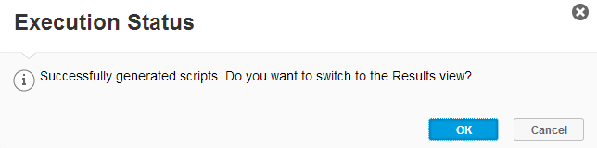

After you confirm with *OK*, you are directed to the results area.

1. Analyze the results

After you have run the algorithm successfully, you will analyze and interpret the results.

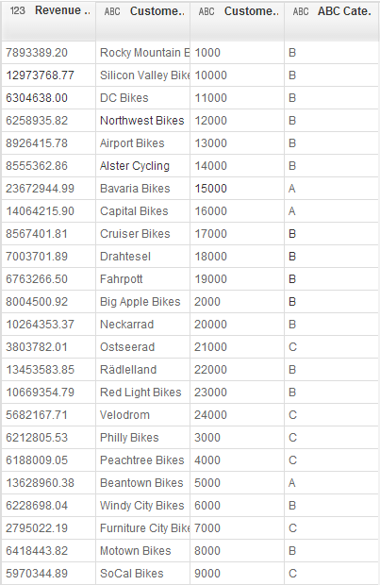

* 1. Check and interpret the data

1. Who are your best three customers?
2. What is the revenue of the company, “Bavaria Bikes”?
   1. Save the document

You can save the analysis within the menu under *File 🡪 Save as* or by clicking on *Crtl + Shift + s.* The name of the file should be ABC_Analysis_## (where ## is your group number).

1. Visualize your results

You have written the results into HANA, using a HANA data writer. Now you want to visualize the results to prepare a presentation for the Chief Marketing Officer.

* 1. Create a new document in SAP Predictive Analysis

**Hint**: You can create a new document using the menu path *File -> new*, or by clicking on the  button.

* 1. Select SAP HANA as data source

Select “Connect to SAP HANA”

Enter the logon information

**Server:** *Provided by the instructor*

**Instance/Port:** *Provided by the instructor*

**User:** *Provided by the instructor*

**Password:** *Provided by the instructor*

Connect to SAP HANA.

* 1. Select the table

Select the table ABC_## from your database schema

Click on *CREATE*.

* 1. Choose the VISUALIZE tab

Click on the *VISUALIZE* tab on the top of the workspace.

* 1. Create a Measure

Go to the “Revenue in EUR” dimension and click on options.

**Hint:** The symbol for options  appears when you move the cursor over the symbol.

From the context menu chose “Create a Measure”

* 1. Change the Measure type

Under *MEASURES,* go to the new created measure “Revenue in EUR” and click on options . From the context menu go to “Change Aggregation” and choose “None”

**Hint:** The aggregation “None” appears at the end of the measure.

* 1. Create a visualization

Drag and drop the Measure “Revenue in EUR” to the X-Axis and the Dimensions “ABC_CATEGORY” and “Customer name” into the Y-Axis. Change the visualization from a column chart to a line chart.

**Hint:** The visualization can be changed in the left upper part of the work screen 

1. Create a presentation for the Chief Marketing Officer

You want to present your results to the Chief Marketing Officer to convince him to treat his best customers even better.

* 1. Change to COMPOSE

Click on the *COMPOSE* tab at the top of your workspace.

* 1. Select a blank board as page type

Enter ABC Analysis XXX as name for the board.

Select *BOARD* and *BLANK* and create the board.

* 1. Add the previously created visualization

Drag the previously created visualization from the toolbar at the left hand side and drop it into the middle of the screen.

* 1. Add a simple text field to the presentation

Select *TEXTS* from the toolbar on the left hand side.

Add a simple text field below the Board Title by drag and drop of the *SIMPLE TEXT* button from the left hand side to the workspace.

Change the text to:

“Increase sales numbers:

* 20/80 rule: prioritize A-customers
* Display categorization of customer to service agent when a customer calls
* Find cross- and upselling strategies”

Adjust the size of visualization by clicking on the border of the text field and dragging it up.

* 1. Change the board title

On the workspace, change to board title to “Customer Analysis”.

* 1. Preview the presentation slide

On the top of the workplace change from Edit to View by clicking on the button .

* 1. Save your presentation

You want to save your presentation and present it to the CIO later on.

Click on File -> Save as and save you document under the name “ABC Analysis XXX” locally.